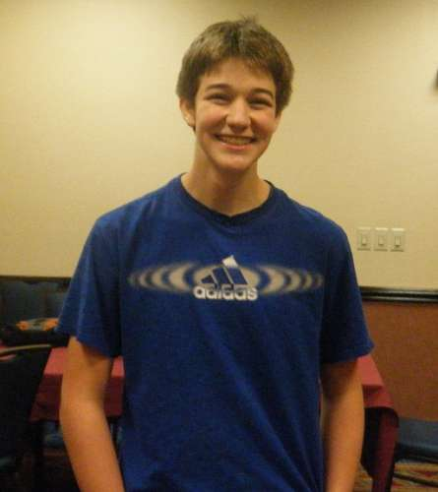

**Griggs and Boor Ohio Co-Champions**

Even though the Ohio Chess Congress is a state championship event, it tends to draw players from various states. Of the 117 players in the recently completed Congress, 16 were from out of state, including the top rated player in the tournament Alex Zelner of Florida.

When the dust settled, Zelner, Carl Boor, and Walker Griggs finished in a three way tie for first place. Since Zelner is not an Ohio resident Boor and Griggs were declared Ohio Co-champions. This is the third championship for Boor and the first for Griggs. Griggs is an amazing story having only played rated chess since 2009. He is the second youngest Ohio Champion at the age of 15.

Taking top honors in the under 2000 section was ten year old Maggie Feng. First in the under 1700 section went to Blair Koman and scoring a perfect 6-0 in the under 1400 section was Ben Tancinco. John Hughes finished first in the Ohio Blitz Championship.

Griggs-Zelner

1. d4 Nf6 2. Bg5 e6 3. e4 Be7 4. Nd2 0-0 5. Bd3 h6 6. Bh4 d5 7. e5 Nfd7 8. Bxe7 Qxe7 9. c3 c5 10. Ngf3 cxd4 11. cxd4 Nc6 12. a3 a5 13. Nf1 f6 14. exf6 Qxf6 15. Ne3 Nxd4 16. Bh7+ Kxh7 17. Qxd4 Qxd4 18. Nxd4 Nb6 19. Nf3 Bd7 20. 0-0 Rac8 21. Rfe1 Rf4 22. Rad1 g5 23. Ne5 Be8 24. Rc1 Re4 25. Rxc8 Nxc8 26. N5g4 Kg7 27. f3 Rd4 28. Ne5 Ne7 29. N3g4 h5 30. Nf2 Rd2 31. Ned3 Bf7 32. b4 axb4 33. axb4 Nc6 34. b5 Nd4 35. b6 Ra2 36. Nc5 Rb2 37. Nxb7 Rxb6 38. Nc5 Rb2 39. Nfd3 Rc2 40. Nd7 Bg6 41. N3e5 g4 42. Nxg6 Kxg6 43. Ne5+ Kf5 44. fxg4+ hxg4 45. Nd3 Ne2+ 46. Kf1 Rd2 47. Rxe2 Rxd3 48. Rf2+ Kg5 49. Re2 Kf6 50. Rf2+ Ke5 51. Re2+ Kd6 52. Ra2 e5 53. Ra8 d4 54. Rg8 g3 55. h4 e4 56. h5 Rd1+ 57. Ke2 Rh1 58. Rxg3 Rxh5 59. Rg8 Ke5 60. Ra8 Rh2 61. Re8+ Kd5 1/2 - 1/2

Alan Casden  Ariel Olek

1. g3 Nf6 2. Bg2 g6 3. c4 Bg7 4. Nf3 O-O 5. O-O c6 6. Nc3 d5 7. d4 dxc4 8. Ne5 Be6 9. e4 Qc8 10. Qe2 Nfd7 11. f4 Nxe5 12. fxe5 b5 13. Be3 Bh3 14. Rad1 Na6 15. a3 Nc7 16. Bf4 Bxg2 17. Qxg2 Ne6 18. Be3 a6 19. h4 c5 20. Nd5 Qb7 21. dxc5 Rac8 22. Qf2 Bxe5 23. h5 Ng7 24. Nb6 Rc7 25. h6 Nh5 26. Qxf7+ 1-0